Hello Pre-K 1 Families,
We will continue our ocean unit this week. The kids had fun learning about the ocean zones. Ask them to tell you the zones and what lives there! We also had fun making an “ocean” on a graham cracker and eating it! We will create some fun ocean art and take a look at what different groups of ocean animals are called (school of fish, pod of dolphins, etc.)
We will also be dying eggs this week and, if the weather cooperates, hopefully we will get to have an egg hunt on the playground towards the end of the week.
The Art Show is Monday evening from 5:30-6:30p.m. at the University of Wyoming Art Museum. It will be held on the lower level—just enter doors on the ground floor.
The Parent/Teacher Conference sign-up sheet is up on the board. Conferences are in the morning and evening of April 3rd and Thursday, April 5th in the morning.
Our last day of swimming is on Tuesday. Thank you for bringing in bike helmets, we hope to ride bikes soon! Please hold the date for class and individual pictures on April 25^{th.} Class picture time is TBD. I will let you know as it gets closer.
Upcoming Dates:
- Art Show- March 26th, 5:30-6:30 p.m.
- School Closed April 2nd and 3rd, P/T Conf. April 3rd
- Graduation/Year End Celebration –May 16th 6p.m.

Have a good weekend!
-Miss Laura
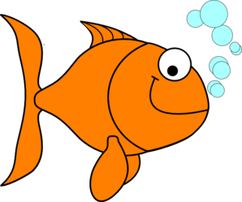

Library- Thursdays
Movement- Mondays
Music-Wednesdays
Cooking-Mondays
Swimming/Spanish-Tuesdays
Art- Fridays

