Hello Pre-K 1 Families,
We will start a two week unit on Oceans as we come back from Spring Break. We will look at ocean environments and the sea creatures that live in them as we learn which ocean zone they can survive in. We will create an ocean in a cup for our cooking snack.
Our bike helmet policy will begin on March 19th. Please bring your child’s helmet to school if they would like to ride bikes during the day –weather permitting! Our Art Show will be March 26th from 5:30-6:30p.m. at the University of Wyoming Art Museum. It will be held on the lower level—just enter doors on the ground floor, no need to climb the stairs.
Parent/Teacher Conferences will be held on April 3rd and various morning times during the first week of April. Sign-up sheets will be up in the classroom this week.
Our last day of swimming is March 27th. Hopefully we will be able to take a few walks to the park and some more field trips on Tuesday afternoons as we finish up the school year.
Upcoming Dates:
- Art Show- March 26th, 5:30-6:30 p.m.
- School Closed April 2nd and 3rd, P/T Conf. April 3rd
Hope you all had a nice week! I’m looking forward to seeing everyone soon!
-Miss Laura
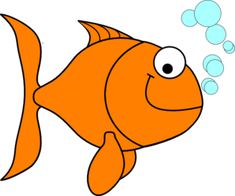

Library- Thursdays
Movement- Mondays
Music-Wednesdays
Cooking-Mondays
Swimming/Spanish-Tuesdays
Art- Fridays

