Pre K 1 – Spring Unit/Mini Lesson Plan
- Letter Sounds https://www.youtube.com/watch?v=BELlZKpi1Zs&t=78s
- Sight Word song https://www.youtube.com/watch?v=f8Yom1m0830
- https://www.youtube.com/watch?v=hlzvrEfyL2Y (Mr. Sun-a song we like to sing)
- Have children clap syllables, then say the word again, slowly and ask if they know what letter it starts with.
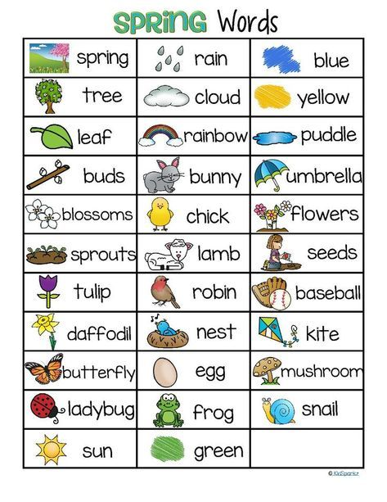

- Literacy Activity – Make chalk paint—In a muffin tin pan mix equal parts cornstarch and water in each tin, add food coloring and mix. Kids can use paint brushes to design their own creations or write names and letters
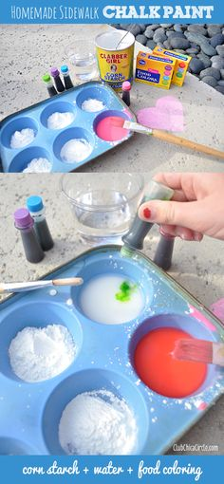

- Science Activity- This is a fun activity we have done in class: Take a 2-liter pop bottle or juice bottle, fill ¼ full of vinegar. In an uninflated balloon have child hold the opening while you add baking soda. Carefully put balloon lip around top of bottle and shake baking soda into bottle—watch the balloon inflate itself!!

- Math Activity – Dice activity
Have child roll two die and count how many dots-- then using candy, Legos or other small manipulatives count out the number. Continue to roll and count as high as they can. Take it a step further and have them write numbers on white board (some numbers like 2, 5 are tricky so they may need help)
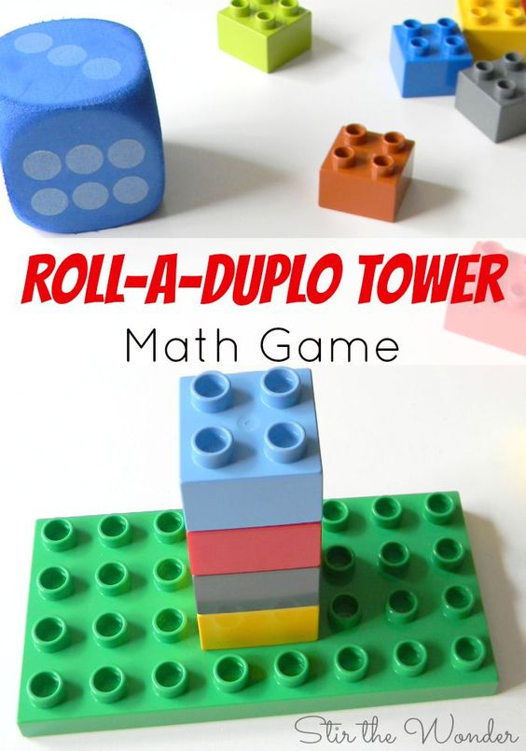
- Art --Coffee filter flowers 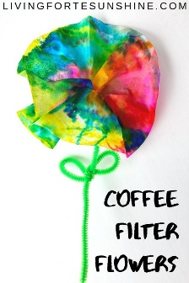
Kids can color a coffee filter with Sharpies (vibrant colors work best), make sure the coffee filter is on a surface where it won’t bleed through. Then have children spray water on filter, let air dry. Attach pipe cleaner or glue on a large piece of paper and continue making more for a collage effect. Beautiful!!

