Pre-K 1 – Space/ Mother’s Day /Mini Lesson Plan

- Rocket Tracing Letters --https://www.worksheetfun.com/letter%20and%20numbers/Tracing_capital_letters_rocket_1.pdf
Straw Rocket printable: https://attachments.convertkitcdnm.com/3745/4054bcb0-6bf5-47f7-95ea-7fd1dde51aa3/Rocket%20Printable.pdf
To create the rockets, you will need the following supplies:
- heavy paper or cardstock
- scissors
- tape
- plastic straws (bendy or straight)
You can print the rockets on white cardstock and your kids can decorate and color them, or you can print them on colored paper.
After cutting out the rockets and rectangles, place a rocket on the table with the print facing down. Place a drinking straw in the middle of the rocket and place a rectangle on top of the straw. Tape the long edges of the rectangle to the back of the rocket. It should look like a little tunnel for your straw just like the picture below. 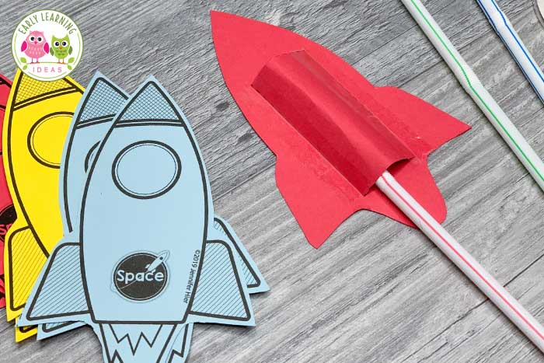
- Mother’s Day card printable- Kids can color a card for their sweet mom!
https://usercontent.flodesk.com/1b1236b4-ab66-45a1-8b10-aa4be5353129/upload/mothers-day-coloring-cards-1902_1a0a9f2e-da41-4562-a4e5-04fb11da5766.pdf

