Pre-K 1 – Space Unit/Mini Lesson Plan
- The Solar System Song https://www.youtube.com/watch?v=BZ-qLUIj_A0
- Space Color sheets https://www.simpleeverydaymom.com/wp-content/uploads/2014/10/space-coloring-pages.pdf
- Math Activity –Space Ice Cream! Not really, but it’s a fun activity with “ice cream” and counting Kids can first color in the ice cream scoop on the first page that is the larger number (more) on the second page they can color in the ice cream scoop that is smaller (less). Then cut out the scoops and cones with numbers and practice number correspondence as they stack that many scoops on top of the cone. You can also use pom poms or small items instead of cutting out scoops to save time. https://thekindergartenconnection.com/wp-content/uploads/2020/04/Ice-Cream-More-or-Less-4-26.pdf

- Literacy activity— Sprinkle baking flour or rice in a tray, using their pointer finger have kids write their name, letters, or sight words 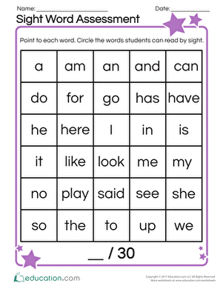

Hands on Activities – to avoid too much mess and clean up, have kids do these activities at a table
- Galaxy Milk: Fill the bottom of a glass pie dish with milk. Drip a few different colors of food coloring in the milk. Dip the end of a Q-tip into liquid dish soap (Dawn works best if you have it available). Stick the Q-tip with dish soap into the milk. Watch the colors begin to swirl together. Stick the Q-tip into another spot in the milk to watch more color swirl together. Keep moving the Q-tip around to create an outer space galaxy in the pie dish!

- Moon Dough: To make homemade moon dough, mix 1-part conditioner and 2 parts cornstarch together. Add a few drops of food coloring to the mixture and work it all together by squishing it with your hands. The consistency will be like a super soft, squishy play dough that will lose its form when not in use for a time period. Let your preschooler play with it on the table or a tray!
- Art -Print out these circles and have kids use watercolors or markers, crayons or paint to create their own planets https://modernpreschool.com/wp-content/uploads/2020/04/clip-the-planet.pdf if you have black paper kids can glue their planets on the paper after they dry. If your not afraid of using glitter add it for stars and fun.

