Pre K 1 – Oceans Unit/Mini Lesson Plan

- Letter Sounds https://www.youtube.com/watch?v=BELlZKpi1Zs
- Ocean words—help child clap syllables in each
word
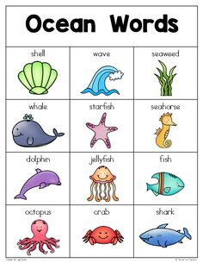
- Read : Scientist think there are ONE MILLION species of animals that live in the ocean! There are 5 oceans on Earth—Pacific, Atlantic, Indian, Artic and Antarctic Ocean. Some of the smallest and largest animals live in the ocean. Plants like seaweed, algae and kelp can be found in the ocean too. Did you know? The largest animal on Earth can be found in the ocean? It’s the Blue Whale! Ask children what their favorite animal that lives in the ocean is? Ask them to think about how they see, what they eat, how they breath.

Writing
- Have children practice their names and writing ocean words from above.
- Salt writing idea, write names or create sea creatures – https://www.iheartartsncrafts.com/jellyfish-salt-painting-activity-kids/

Math
- We were working on teen numbers! If you have goldfish crackers, these are a great manipulative for counting and tracking numbers. Other crackers/ items work as well.
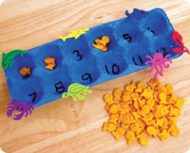

Movement - Play sharks and minnows- someone is the shark trying to catch the minnows in the sea
Sensory- Make salt dough starfish! 2c. flour 2c. salt 1 c. water, mix all ingredients together. Help children shape into starfish or other ocean creatures. Let dry. Later, they ycan paint them fun colors.

