 | November 2019
Sun | Mon | Tue | Wed | Thu | Fri | Sat
 |  |  |  |  | 1  Science Kitchen – morning  Art - afternoon | 2
3 | 4  Healthy Kids Rx - afternoon | 5  NORMAL HOURS AT OPEN SCHOOL  (District closed)  Swimming - afternoon | 6  Spanish – morning  Music - afternoon  Staff Meeting – Library 6 p.m. | 7  Music – morning | 8  Art - afternoon | 9
10 | 11  Healthy Kids Rx - afternoon | 12  Swimming - afternoon  Board Meeting – 5:30 p.m. | 13  Spanish – morning  Music - afternoon | 14  Library - afternoon | 15  Art - afternoon | 16
17 | 18  Healthy Kids Rx - afternoon | 19  Swimming – afternoon | 20  Spanish – morning  Music - afternoon | 21  Music - morning | 22  Art Museum - afternoon | 23
24 | 25  Healthy Kids Rx - afternoon | 26  Charlie Brown Thanksgiving -  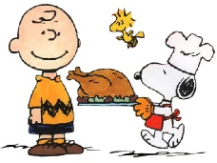  Afternoon | 27  CLOSED  HAPPY THANKSGIVING | 28  CLOSED | 29  CLOSED | 30

