The Open School
November 2018
Sun | Mon | Tue | Wed | Thu | Fri | Sat
 |  |  |  | 1 | 2 | 3
4 | 5  Healthy Kids Rx afternoon | 6  Swimming afternoon | 7  Spanish morning  Music afternoon | 8  Library – (book check out) – aft. | 9  UW Art Museum afternoon | 10
11 | 12  Healthy Kids Rx afternoon | 13  Swimming afternoon  Domino’s Pizza Night  Board Meeting 5:30 p.m. | 14  Spanish morning  Music afternoon | 15  Charlie Brown Thanksgiving - afternoon | 16  Fire Drill and Assembly  Art afternoon | 17
18 | 19  Healthy Kids Rx afternoon  Staff Meeting 5:30 p.m. | 20  Last Swimming afternoon  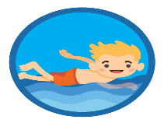 | 21  Closed for Thanksgiving | 22  Happy Thanksgiving  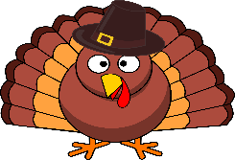 | 23  Closed | 24
25 | 26  Healthy Kids Rx afternoon | 27 | 28  Spanish morning  Music afternoon | 29  Library Storytime afternoon | 30  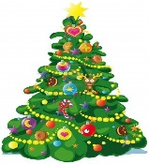  Art afternoon  Festival of Trees afternoon | Happy Holidays Laramie at  UW Art Museum

