Pre-K 1 – Insect Unit/Mini Lesson Plan
- Letter Sounds https://www.youtube.com/watch?v=BELlZKpi1Zs&t=78s
- Apple and Bananas Vowel song https://www.youtube.com/watch?v=r5WLXZspD1M
- I Love the Mountains https://www.youtube.com/watch?v=mmjbF3A30eQ
Independent activity—Using a dropper, like for water or medicine, have child drop water dots on a penny or draw circles on paper and place on baking pan with lip and count how many water dots stay on it without going over edge of penny or circle.
- Literacy Activity – Kids will need a little extra help with this one, but I think they will enjoy it as they are getting older. Cut out ladybug syllable cards then read the sight words, have child clap or count on fingers syllables in words. Have them match syllable count to dots on ladybug. Put a chip clip or clothespin on correct word. Example: “Let’s read these words together and see if we can find a three sound word to match the dots on the ladybug. “Fly” (clap once) no that has one clap sound. “Anything” (clap one, two, three) yes that is a three-clap word. Good job”
Take it an extra step and have child write down words on recording sheet at end of post. https://thekindergartenconnection.com/wp-content/uploads/2017/01/Ladybug-syllable-clip-cards-secure.pdf
- Science Activity- Try this fun static electricity experiment if you have tissue paper and a balloon https://iheartcraftythings.com/static-electricity-butterfly-experiment.html

- STEM Activity – Playdough and plastic Easter eggs? Have children try a build a tower as high as they can using the playdough like glue between Easter eggs. 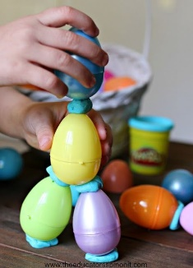
- Math Activity- Cut/ or have child cut cards out. Practice counting and recognizing what makes 10. https://thekindergartenconnection.com/wp-content/uploads/2016/03/Making-10-Puzzles-Bee-Theme.pdf Extend the activity by giving kids whiteboards, writing numbers down as they recognize them.

