 | February 2020
Sun | Mon | Tue | Wed | Thu | Fri | Sat
 |  |  |  |  |  | 1
2 | 3  Healthy Kids - afternoon | 4  Swimming begins – afternoon  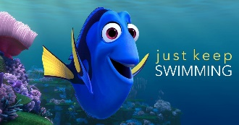  Staff Meeting 5:30 p.m. | 5  Music - afternoon | 6  Spanish – morning  Library - afternoon  Domino’s Night | 7  Art - afternoon | 8
9 | 10  Healthy Kids - afternoon | 11  Swimming – afternoon  Board Meeting 5:30 p.m. | 12  Music - afternoon | 13  Spanish – morning  Fire Drill &  School Assembly –  Kindness Celebration - afternoon | 14  ½ DAY DISMISSAL 11:30  VALENTINE’S DAY PARTIES | 15
16 | 17  SCHOOL CLOSED  DISTRICT WIDE | 18  Swimming - afternoon | 19  Music - afternoon | 20  Spanish – morning  Library - afternoon | 21  Art Museum - afternoon | 22
23 | 24  Healthy Kids - afternoon | 25  Swimming - afternoon | 26  Music - afternoon | 27  Spanish – morning | 28  Art - afternoon | 29

Upcoming – Spring Break – March 16-20

