Pre-K 1 – Easter Unit/Mini Lesson Plan
- Letter Sounds https://www.youtube.com/watch?v=BELlZKpi1Zs&t=78s
- Opposite song https://www.youtube.com/watch?v=HGeuA4iJ8vI
- Peter Cottontail https://www.youtube.com/watch?v=q7UXYvRRZFc&t=2s
- Independent Activity- water play, filling a small tub with soap and water and play objects (also works with bean, rice, etc.)

- Literacy Activity – Cut out, or have child cut out as they practice scissor skills, letter eggs and place plastic eggs. Hide eggs around house and have child find them. If you don’t have plastic eggs just hide paper letter eggs. You can also play a matching game between capital and lowercase letters. https://thekindergartenconnection.com/wp-content/uploads/2020/04/Sunday-Surprise-4-5.pdf

- Science Activity- Fizzing eggs https://www.funathomewithkids.com/2014/03/magic-easter-eggs-two-ways-hatching-and.html?m=1 This project takes a couple of days—the baking soda eggs have to dry before dissolving with vinegar 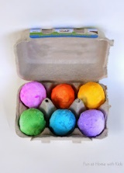

- STEM Activity – Create 2-D and 3-D shapes with jelly beans or marshmallows and tooth picks https://www.pinterest.com/pin/101471797841624397/
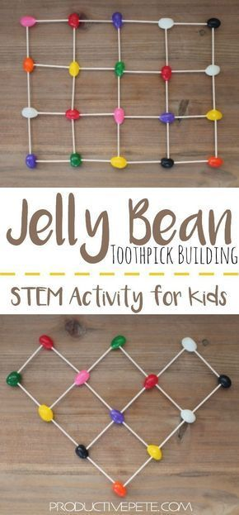

- Cooking- Make Rice Krispies and have child help shape them into “birds’ nest” and place yummy candies inside “nest”
-Make Jell-O Jigglers https://www.food.com/recipe/jell-o-jigglers-84471

