 | December 2018
 | Mon | Tue | Wed | Thu | Fri | Sat
1
Festival Of Trees
UW Art Museum
2 | 3  Music -morning  Healthy Kids Rx - afternoon  (last one until January) | 4 | 5  Spanish -morning  (last until January)  Music - afternoon | 6  Gingerbread Houses - afternoon | 7  Art Museum - afternoon | 8  Gingerbread Jamboree  Ivinson Memorial Hospital
9 | 10  Rehearsal Gryphon Theatre Civic Center at 9:30 a.m. | 11  Domino’s Pizza Night | 12  Peppermint Parade 5:45 p.m. Gryphon Theatre Civic Center | 13  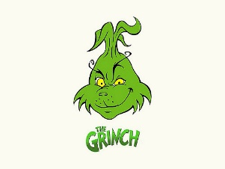  Movie Party Afternoon | 14  Art – afternoon | 15
16  (Miss Shelly gone 17-21) | 17 | 18 | 19 | 20 | 21  Art - afternoon | 22
23 | 24  NO SCHOOL UNTIL  JANUARY 7TH  WINTER BREAK | 25  MERRY CHRISTMAS | 26  NO SCHOOL | 27  NO SCHOOL | 28  NO SCHOOL | 29
30 | 31  NO SCHOOL  HAPPY NEW YEAR’S | CHRISTMAS/WINTER BREAK – DECEMBER 22-JANUARY 6TH  SCHOOL RESUMES JANUARY 7, 2019

